**DQC_0015 Negative Values Rule:**

Negative Values Presented in a Consolidated Financial Information Footnote

Currently negative values tagged with Consolidation Items [Axis] / Consolidation, Eliminations [Member] combination are exempted from the DQC_0015 Negative Values rule.

**Consider including exemptions for all the members in a consolidation.**

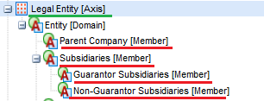

It is not unusual to see negative values presented in other members in a consolidation. The values of these members aggregate to the consolidated facing financial amount, which is tagged with a standard element.

Example 1:NABORS INDUSTRIES LTD CIK#: [0001163739](http://www.sec.gov/cgi-bin/browse-edgar?action=getcompany&CIK=0001163739&owner=exclude&count=40) 10-Q 09/30/2014

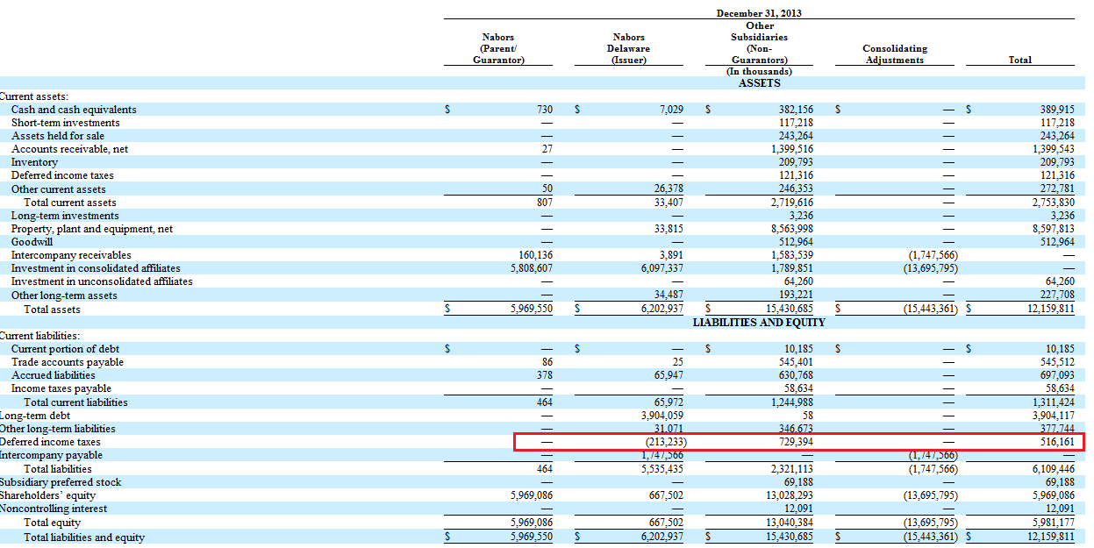

Example 2: BON TON STORES INC CIK#: [0000878079](http://www.sec.gov/cgi-bin/browse-edgar?action=getcompany&CIK=0000878079&owner=exclude&count=40) 10-Q 05/02/2015