DQC_0015 Negative Values Rule:
Currently all elements under the Provision for Loan, Lease, and Other Losses [Abstract] have been excluded from DQC_0015 rule, except for us-gaap_ProvisionForLoanLossesExpensed.
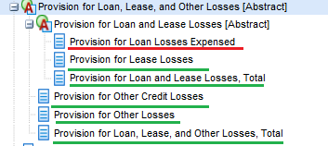
Consider excluding us-gaap_ProvisionForLoanLossesExpensed from DQC_0015.
This line item often includes reversal, resulting in a net credit rather than expense for the period.

Example 1: Federal Home Loan Bank of New York CIK#: 0001329842 10-Q 09/30/2014
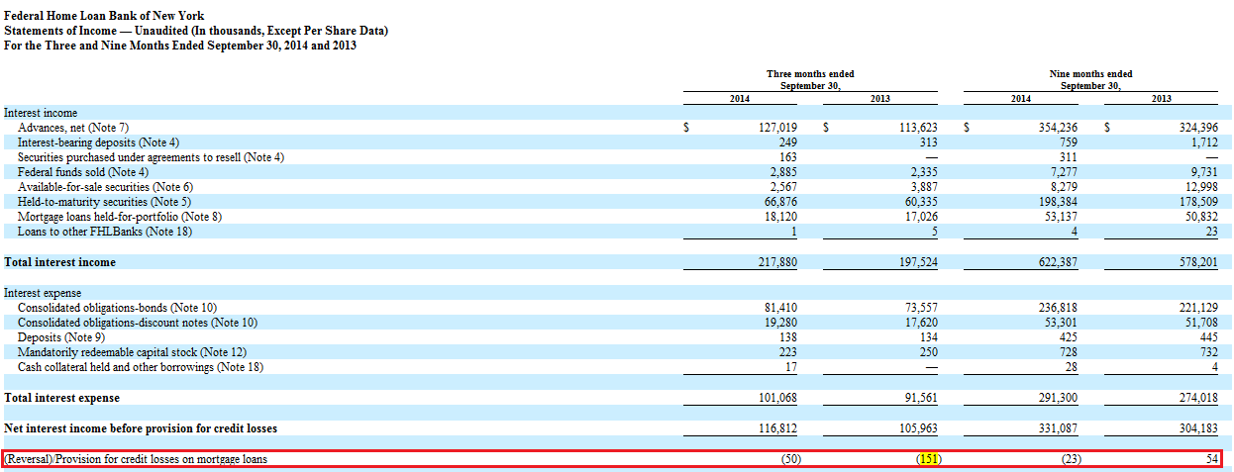

Example 2: Beneficial Bancorp Inc. CIK#: 0001615418 10-Q 03/31/2015
