DQC_0013 Negative Values with Dependence:
Consider removing element us-gaap_EffectiveIncomeTaxRateReconciliationNondeductibleExpense from this rule.
DQC_0015 does not include the element: us-gaap_IncomeTaxReconciliationNondeductibleExpense (monetary element) because not all the components of this element are subject to DQC_0015. For example, the component IncomeTaxReconciliationNondeductibleExpenseShareBasedCompensationCost often includes reversal and thus a negative value is allowed.
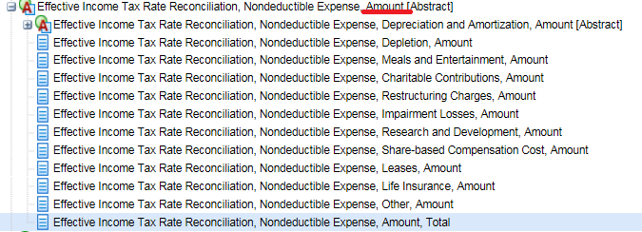
We believe the same methodology should be applied to the “percent” type element.

Example: Wesco Aircraft Holdings, Inc. CIK#: 0001378718 09/30/2015 10-K
