DQC_0015 Negative Values:
Consider removing element us-gaap_RecognitionOfDeferredRevenue from this rule.
While we agree that values should generally be positive for this element, occasionally we see negative values in the interim financial statements, possibly due to timing of invoicing or reversal. See example below:
Example: HCP, Inc. CIK#: 0000765880
09/30/2014 10-Q (interim financial statements)
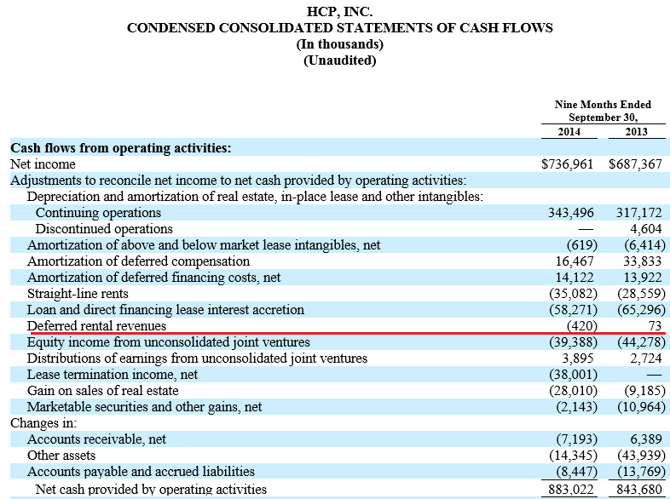
12/31/2014 10-K (year-end financial statements)
